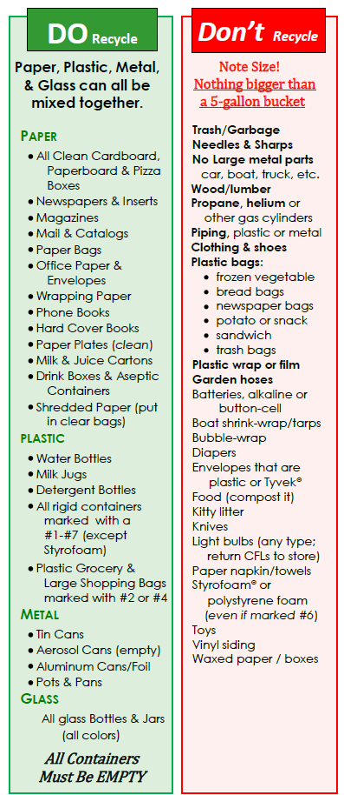

**We now accept Paint Products**

**PaintCare Products Accepted:**

* Interior and exterior architectural

paints: latex, acrylic, stains

* water-based, alkyd, oil-based,
* Enamel, deck coatings, floor paints
* Primers, sealers, undercoaters
* Shellacs, lacquers, varnishes,

urethanes (single component)

* Waterproofing concrete/masonry/wood

sealers and repellents

* Metal coatings, rust preventatives
* Field and lawn paints

**Non-PaintCare Products**

* Paint thinners, mineral spirits, solvents, deck cleaners
* Aerosol paints, caulking compounds, epoxies, glues, adhesives
* Paint additives, colorants, tints, resins wood preservatives (containing pesticides)
* Asphalt, tar and bitumen-based products, roof patch, traffic and road marking paints
* Industrial Maintenance (IM) coatings

**Know Which Plastics to Recycle**

With the exception of Styrofoam, your plastic is recyclable

if the answer to **all** three questions are **YES:**

1. Does it have a number 1-7 in the middle of the chasing arrow?
2. Is it rigid or hard?
3. Is it a container?



**TOWN OF FRYEBURG**

**TRANSFER STATION**

2025 Main Street

Fryeburg, ME 04037

Revised: 12/12/2019

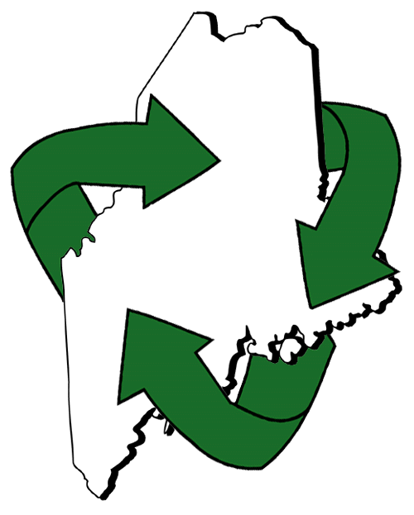

**TRANSFER STATION HOURS:**

Monday: 7am – 4pm

Tuesday: closed

Wednesday: 7am – 4pm

Thursday: closed

Friday: closed

Saturday: 7am – 4pm

Sunday: 7am – 4pm

***Closed all legal holidays & Easter***

**TRANSFER STATION POLICIES:**

**Mandatory Vehicle Stickers:**

All vehicles must have a sticker placed on the *driver’s side of the windshield* in order to use the Transfer Station facility for any disposal. The annual Transfer Station sticker costs Fryeburg residents $20. The **RED** sticker has the license plate number printed on it and identifies Fryeburg residents to allow for trash disposal from September 1, 2019 to August 31, 2020.

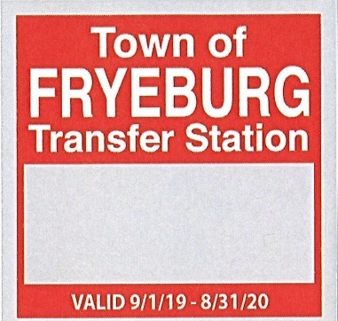

**Methods of Payment:**

* ***Punch Cards***- Punch cards can be purchased at the Town Office. Transfer Station attendants will punch out the amount needed to pay for the disposed items. Punch cards come in $10 or $25 amounts.
* ***Checks***- There will be a returned check fee of $25.00.
* ***Credit cards*-** All credit/debit card transactions under $40 will include a $1.00 user fee; transactions $40 and over will include a 2.5% fee.

**Scales:**

Scales are now being used to more accurately measure demolition debris and wood and various other items such as furniture to determine the associated fee. The cost is 8 cents per pound. If you have a trailer or truck bed full of miscellaneous construction debris and bulky items weighing over 20 pounds total.

*Instruction for scale use:*

Stop before entering the scale, then drive on slowly and stop at the light to be weighed. When the light turns green you may proceed and dispose of your items in the appropriate location. Next you will return to the scale, stop before entering, drive on slowly and stop at light to again be weighed. When the light turns green you may proceed and go see the Transfer Station attendant to pay for the disposal.

**Please Recycle:**

Please help to keep our costs down with single sort recycling. No separation or sorting of materials is needed. All recyclables should be placed in the same recycling container separate from the bagged household trash. Refer to the Recycling Guidelines within this brochure for information on what can and can’t be recycled.

**NO PLASTIC BAGS!**

**Plastic bags are NOT recyclable!**

**FOR MORE INFORMATION:**

**Contact:**

Public Works: 207-935-2772

Transfer Station: 207-935-2660

Town Office: 207-935-2805

Ecomaine: 207-773-1738

[www.ecomaine.org](http://www.ecomaine.org)



**Fees subject to change**